Electricity switch. – center one is for solar power

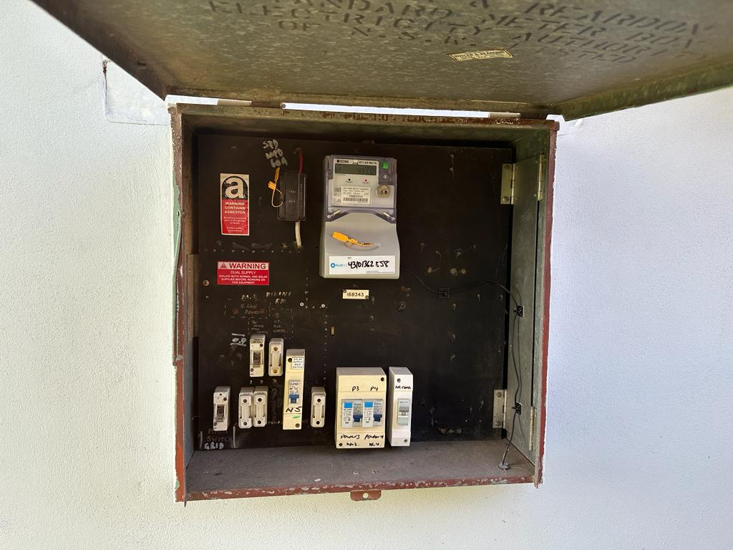

Meter Board is located on the right side of the house .

New installation – in 2022

